Deep Learning Lab 3

Aim:
To implement Gradient Descent for a single neuron using Sigmoid activation and to train AND & OR logic gates using a single-layer neural network.

# Single Input Training using Gradient Descent

Code:
import numpy as np
# Inputs
x1, x2 = 0.6, 0.1
y = 1
# Parameters
w1, w2, b = 0.2, -0.3, 0.4
lr = 40
def sigmoid(z):
return 1/(1+np.exp(-z))
z = w1*x1 + w2*x2 + b
y_pred = sigmoid(z)
dL_dy_pred = y_pred - y
dy_pred_dz = y_pred*(1-y_pred)
dL_dz = dL_dy_pred * dy_pred_dz
dL_dw1 = dL_dz * x1
dL_dw2 = dL_dz * x2
dL_db = dL_dz
w1 -= lr*dL_dw1
w2 -= lr*dL_dw2
b -= lr*dL_db
print(w1, w2, b)
z = w1*x1 + w2*x2 + b
y_pred = sigmoid(z)
print("Y_pred :",y_pred)
Output:

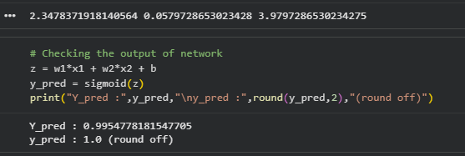

#AND Gate using Gradient Descent

Code:
# AND Gate
import numpy as np
X = np.array([[0,0],[0,1],[1,0],[1,1]])
y = np.array([0,0,0,1])
w = np.array([0.1, 0.2])
b = 0.3
lr = 40
def sigmoid(z):
return 1/(1+np.exp(-z))
for epoch in range(1000):
for i in range(len(X)):
z = np.dot(X[i], w) + b
y_pred = sigmoid(z)
dz = y_pred - y[i]
dw = dz * X[i]
db = dz
w -= lr * dw
b -= lr * db
print("Weights:", w)
print("Bias:", b)
res = sigmoid(np.dot(X, w) + b)
print(res)
Output:

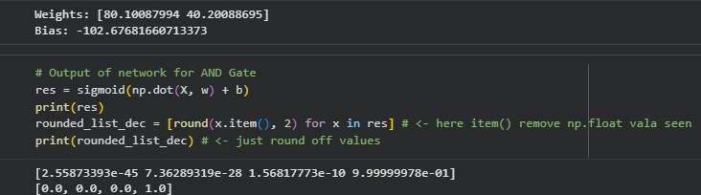

# OR Gate using Gradient Descent

Code:
# OR Gate
import numpy as np
X = np.array([[0,0],[0,1],[1,0],[1,1]])
y = np.array([0,1,1,1])
w = np.array([0.1, 0.2])
b = 0.3
lr = 40
def sigmoid(z):
return 1/(1+np.exp(-z))
for epoch in range(1000):
for i in range(len(X)):
z = np.dot(X[i], w) + b
y_pred = sigmoid(z)
dz = y_pred - y[i]
dw = dz * X[i]
db = dz
w -= lr * dw
b -= lr * db
print("Weights:", w)
print("Bias:", b)
res = sigmoid(np.dot(X, w) + b)
print(res)
Output:

